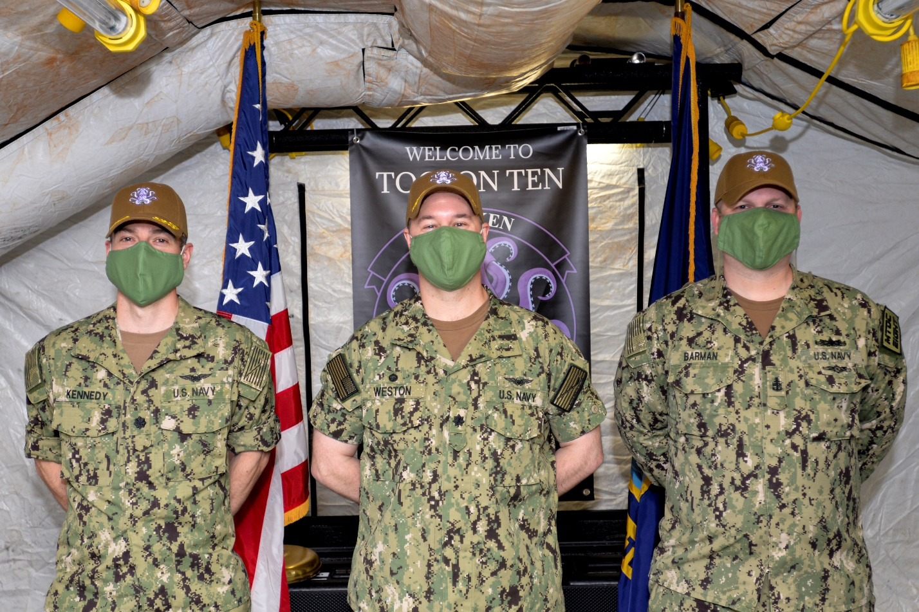
The Tactical Operations Control Squadron TEN leadership (from left to right) Cmdr. Kevin Kennedy, executive officer, Cmdr. Eliot Weston, commanding officer, Senior Chief Petty Officer Adam Barman, stand during the establishment ceremony for TACRON TEN.

FOR IMMEDIATE RELEASE - RELEASE 20-048
June 30, 2020

TOCRON TEN “Kraken” Established at NAS Whidbey Island

NAVAL AIR STATION WHIDBEY ISLAND, Wash. – The Navy stood up its newest tenant command, Tactical Operations Control Squadron (TOCRON) TEN, at NAS Whidbey Island on Friday, June 26, 2020.

Dubbed Kraken, the eight units that comprise this tactical operations control squadron were directly assigned under Commander Patrol and Reconnaissance Wing (CPRW) 10 during the establishment transition. TOCRON TEN is now its own command overseeing tactical operations centers at NAS Whidbey Island and Marine Corps Air Station Kaneohe Bay, as well as six Mobile Tactical Operations Centers (MTOCs).

TOCRON TEN will continue to support P-8 and P-3 squadrons with real-time command, control, communications, intelligence and analysis information for maritime patrol and reconnaissance missions. The Kraken will also support other homeland defense operations in the Pacific.

When CPRW-10 squadrons deploy abroad, they will be accompanied by a TOCRON TEN MTOC detachment. MTOCs are also capable of worldwide expeditionary deployments to remote locations on short notice.

Cmdr. Eliot Weston has been assigned as TOCRON TEN’s first commanding officer. Weston’s last assignment was at Commander Task Force 57 as the chief of operations. Cmdr. Kevin Kennedy, will serve as the unit’s executive officer.

