FOR IMMEDIATE RELEASE - RELEASE 23-022
April 3, 2023

Whidbey SAR Rescues Snowmobiler Near Mount Baker

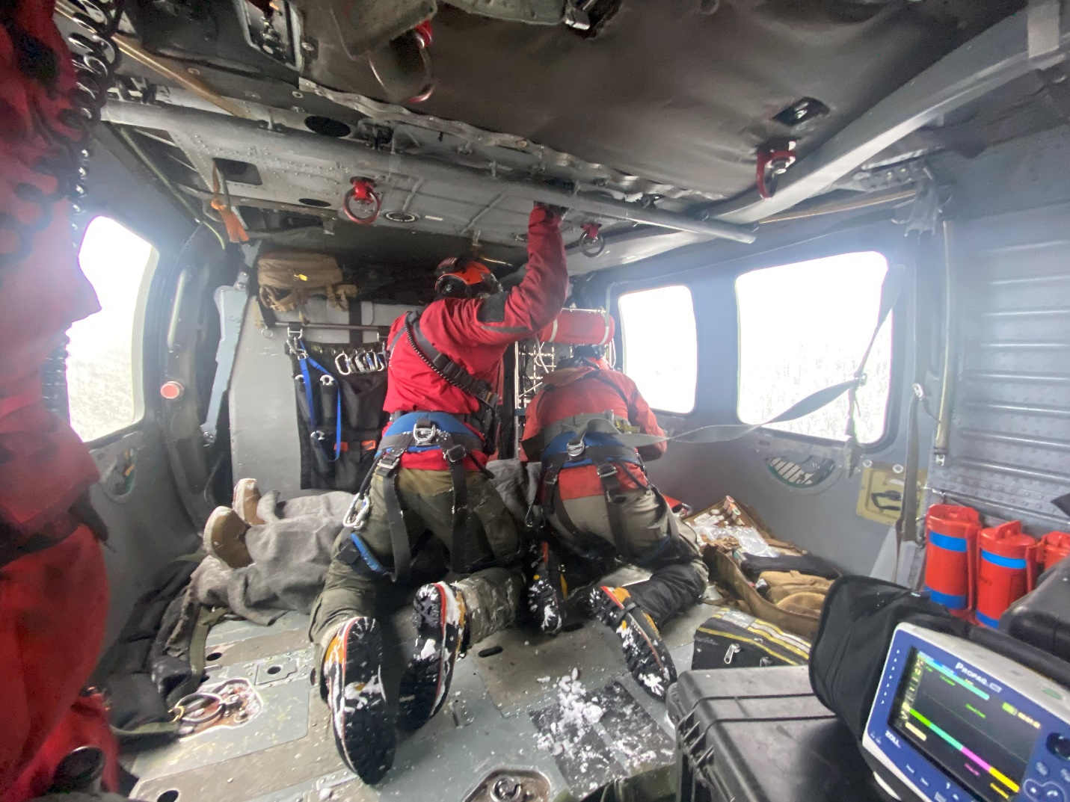

NAVAL AIR STATION WHIDBEY ISLAND, Wash. – A Search and Rescue (SAR) team from Naval Air Station (NAS) Whidbey Island rescued a snowmobiler involved in an accident near Mount Baker, April 1, 2023.

The SAR crew received the request for rescue of the snowmobiler at about 3:40 p.m. and were airborne by about 4:30 p.m.

The SAR crew arrived on scene just before 5 p.m. and had two crew members inserted via the helicopter hoist by approximately 5:05 p.m. The SAR ground crew found the patient was unconscious and had a restricted airway.

At about 5:23 p.m. the SAR crew hoisted the patient and SAR ground crew.

The patient was transported to St. Joseph Medical Center in Bellingham, Wash. by 5:40 p.m.

Naval Air Station Whidbey Island SAR has conducted 5 missions this calendar year, which includes one MEDEVAC, one search and three rescues.

The Navy SAR unit operates three MH-60S helicopters from NAS Whidbey Island as search and rescue/medical evacuation (SAR/MEDEVAC) platforms for the EA-18G aircraft as well as other squadrons and personnel assigned to the installation. Pursuant to the National SAR Plan of the United States, the unit may also be used for civil SAR/MEDEVAC needs to the fullest extent practicable on a non-interference basis with primary military duties according to applicable national directives, plans, guidelines and agreements; specifically, the unit may launch in response to tasking by the Air Force Rescue Coordination Center (based on a Washington State Memorandum of Understanding) for inland missions, and/or tasking by the United States Coast Guard for all other aeronautical and maritime regions, when other assets are unavailable.

Photo courtesy of NAS Whidbey Island SAR: Naval Air Station Whidbey Island Search and Rescue crew members tend to an injured snowmobiler rescued April 1, 2023 near Mount Baker.
###

