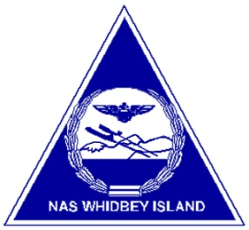
Naval Air Station
Whidbey Island

NEWS
Michael T. Welding
Public Affairs Officer
(360) 257-2286 FAX (360) 257-3972
E-mail: whdb_naswi_pao@navy.mil

FOR IMMEDIATE RELEASE RELEASE 17-142
December 18, 2017

Naval Air Station Whidbey wins Installation Excellence Award Again

NAVAL AIR STATION WHIDBEY ISLAND, Wash. – For the second time in three years, Commander, Naval Installations Command selected NAS Whidbey Island as the Navy’s top large installation this year and the overall recipient for the Navy’s Installation Excellence Award.

NAS Whidbey Island Commanding Officer, Geoff Moore, said the award was welcome surprise.
“This was truly unexpected and we are extremely appreciative of the recognition,” he said. “Each year we simply try to be better than the last, and with great support from both our tenants and our region staff we were able to sustain excellence. Equally, this is an extremely important recognition for our community who do a tremendous job supporting our Sailors and families.”

While this is the second time in the last three years NAS Whidbey Island was recognized with the Navy’s Installation Excellence Award, it is the third year in a row the award was given to a Navy Region Northwest installation. The base will now move on to the Department of Defense level for the Commander-in-Chief’s Annual Award for Installation Excellence, an award it also won in 2016.

The installation excellence award program recognizes the Navy's top three large and small installations, and rewards installation performance in accordance with the command's strategic goals and Office of the Secretary of Defense criteria for the DoD-wide Commander-in-Chief Installation Excellence Awards.

This year's results for Large and Small installations include:

Large Installation

1st Naval Air Station Whidbey Island
2nd Naval Base Coronado
3rd Commander Fleet Activities Yokosuka

Small Installation

1st Naval Air Station Whiting Field
2nd Naval Support Activity Mechanicsburg
3rd Pacific Missile Range Facility Barking Sands

