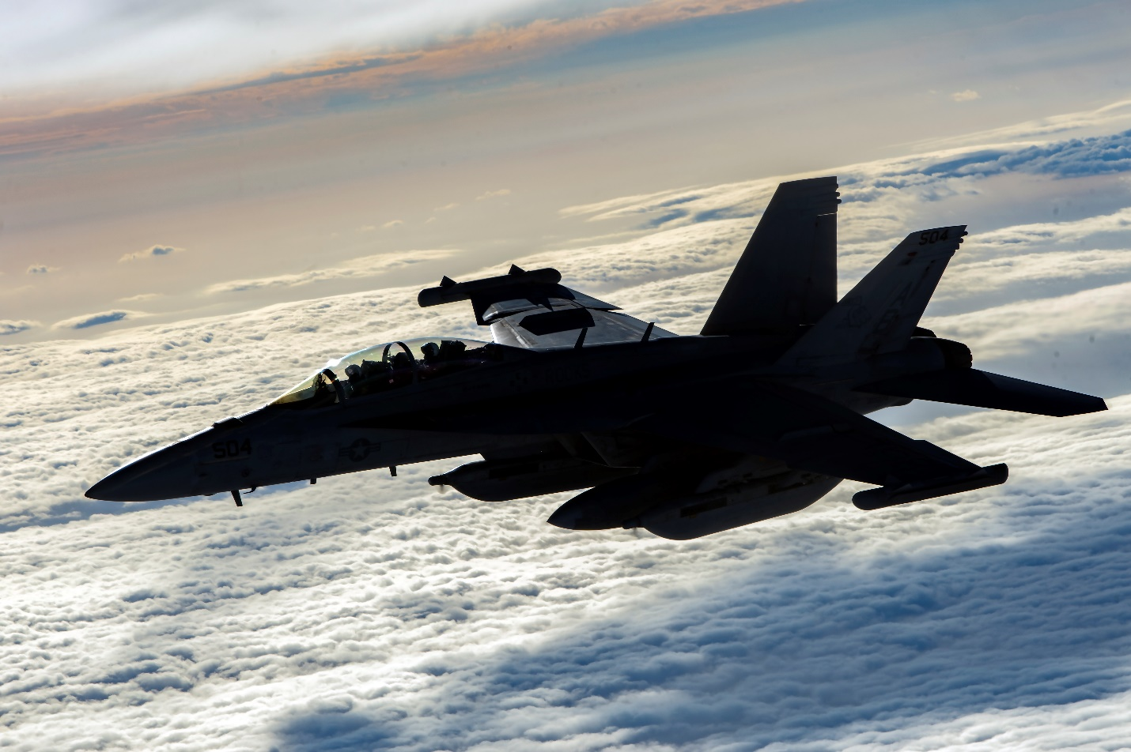
A U.S. Navy EA-18G Growler flies over Afghanistan, Jan. 23, 2020. The EA-18G can perform a wide range of enemy defense suppression missions with the latest electronic attack technology, jamming pods, and satellite communications. (USAF pho by Staff Sgt. Matthew Lotz)

= = = =

Rooks Return to NAS Whidbey Island After Extended Deployment

By LT Brandt Engel, Electronic Attack Squadron 137 Public Affairs

NAS WHIDBEY ISLAND, Wash. -- The “Rooks” of Electronic Attack Squadron (VAQ) 137 returned to Naval Air Station Whidbey Island in June after a seven-month deployment to the 2nd Fleet, 6th Fleet, and 5th Fleet Areas of Responsibility.

The Rooks left NAS Whidbey Island for Norfolk, VA on November 19th 2019, and embarked aboard the USS Harry S. Truman (CVN75). The squadron’s five EA-18G Growlers joined the rest of Carrier Air Wing One and departed with Carrier Strike Group Eight for immediate tasking in the Central Command Theater.

Over the seven month deployment the Rooks maintained a high operational tempo and executed over 1,000 flight hours, including 124 combat hours with a 100% combat sortie completion rate in support of Operation FREEDOM’S SENTINEL. The Rooks participated in the first dual carrier operations in the theater since 2012, and provided deterrence against threats to American interests in the region. On return to the East Coast of the United States, the Rooks took part in a Dynamic Force Employment off Halifax, Nova Scotia in Canada, where they participated in a joint exercise with the Canadian Armed Forces.

None of this would have been possible without the hard work and dedication of the entire Rook Team. Working in stressful and high pressure conditions, the Rook Maintainers kept the squadron’s Growlers mission ready and ensured the squadron operated effectively in the 5th Fleet AOR. The Admin team dealt with a myriad of pay and logistic issues, some on very short timelines, which ensured the Rooks had the right people, in the right place, at the right time. The Rooks led the CSG in Medical Readiness and the Intel team was consistently praised for the classified tasking requirements met. Rook sailors upheld Rook Pride outside the squadron as multiple TAD sailors were recognized at Ship’s Award Quarters for their efforts.

During deployment, the Rooks were treated to some much deserved rest in the port of Duqm, Oman, where the entire squadron took advantage of the sandbox and the freedom to spend some time off the ship.
Nothing was as pleasing to the squadron though as returning home to their friends and family after the constant COVID-19 stress. The Rooks unquestionably proved their Honor, Courage and Commitment during this tumultuous period.

“Every Rook proved themselves as true professionals while weathering a combined 14 months away from home in the last two years during two Dynamic Force Employment deployments,” said CDR Kevin McCarty, Commanding Officer, VAQ 137. “I could not be more proud of their effort, and I will be forever humbled to have been given the opportunity to serve with them.”

